

**USER MANUAL**

**Cyber-Cafe Management System**

**Version 1.0.0**

***Designed and Developed by:***

***Imran Alam***

*7870400632*

*8083299702*

alamimran613@gmail.com

**INTRODUCTION**

**“Cyber-Cafe Management System”** is design to manage **Cyber-Cafe**, Such as: -

* Each System’s time which is use by user.
* Save details for future use.
* Details like: -
* Serial number
* Date
* System No. (Which has used by user)
* User Name
* Address
* Mobile No.
* Login time (Start time of system use)
* Logout time (End time of system use)
* Usage time (Total usage time, in 00:00 (HH:MM) format.
* Finally Update your earnings in Rupees in Account section, here you can update and check Total Earnings and Today Earnings.

You can also search your **saved records** using **search section** which has given on search Records window.

There are two ways to search saved Records, such as: -

* Search by Serial Number.
* Search by User Name.

**Software User-Manual**

1. Start software using CCMS.exe Icon.



1. Then Login window will be show default password is 123 type 123 in password box then hit enter or press **Go** button.

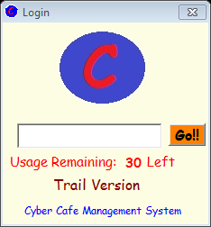

1. Here you can see usage remaining 30 left that means this is trail version software and every time when you login with your software this will subtract 1 that means next time when you login its show Usage Remaining: 29 Left. When this will 0 that means your trail version has been ended.
2. Your Homepage will be shown as given below:

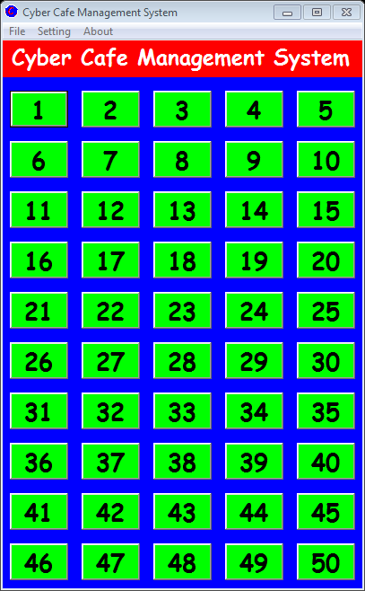

Here you can manage your system information which is use by user its shows 50 systems that means you can manage 50 systems in one time, this is large amount of systems but you can manage it with just click on the buttons.

1. When you click on any system then homepage’s system button’s colour will changed from **Green** to **Red** that means system is engaged and system’s time management window will be show.

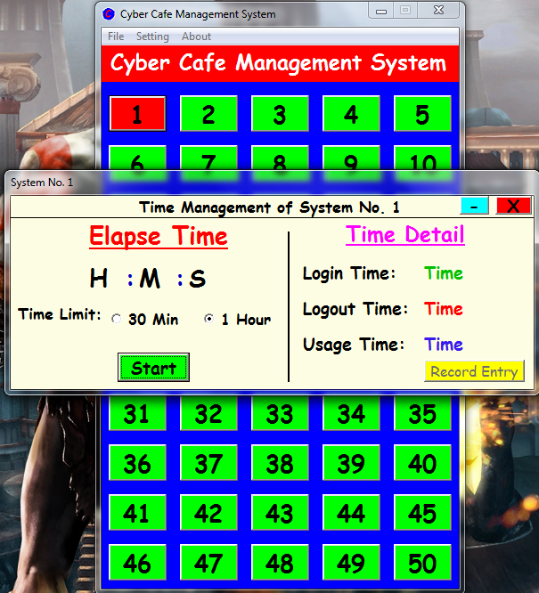

You can press **Start** button for start time for user. Here two options has given one is 30 min and second in 1 hour. Set your time limit and press Start button, when your set time will end then homepage’s system’s colour will be changed from **Red** to **Yellow** that means time limit has ended you can inform to user and press Stop button to stop the timer and press **Record Entry** button to save details of user. When you press **Record Entry** button then Record windows will appear as like that: -

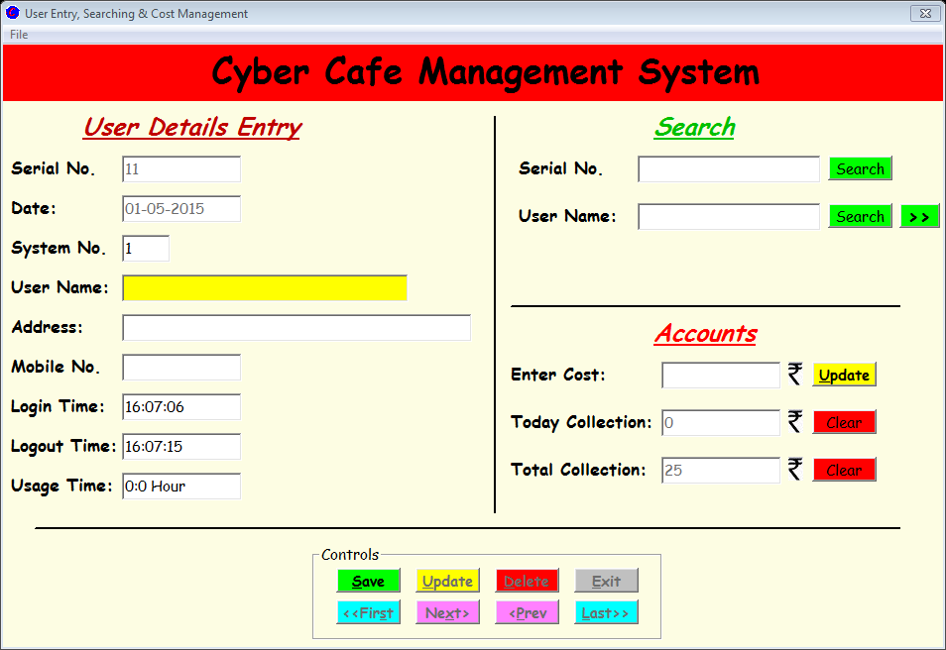

Then enter user name, address, and mobile no. then press save button, after press save button cursor will moved into Accounts section, enter collected funds which is earned by user into **Enter Cost** and press **Update.**

You can also view or manage your records manually, just navigate to **Homepage and press File and press Records.**

You can **print** record using File menu, just click file and click print then a window will be appeared. Just put serial number into bottom of page where serial number 1 is entered automatically and press enter. When you found your record which you want to print the press Print icon, you can found a print icon on top of page.

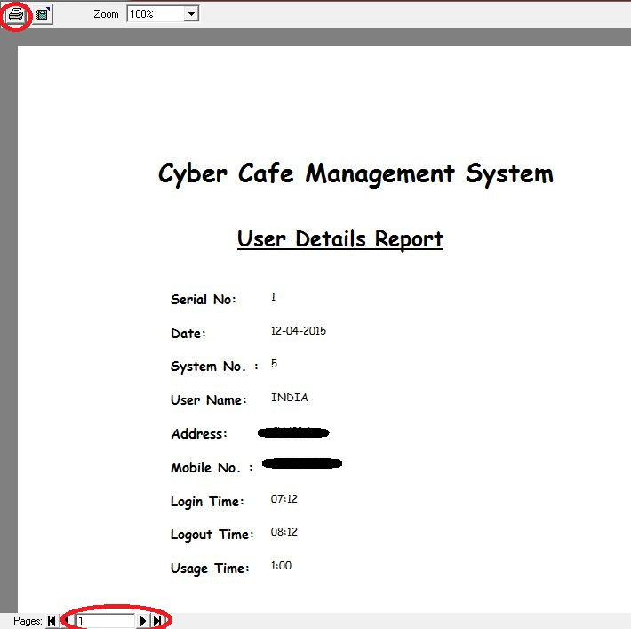

1. When you want to change your password it’s very easy just navigate to **Homepage** and in menu bar you can see **Setting**, just click on it and then click **change password** then a dialogue box will show-

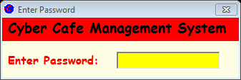

Enter your current password and hit Enter if your entered password will correct then an another dialogue box will appear-

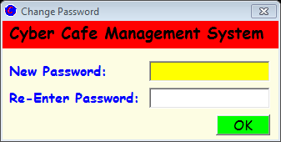

Type your new password and re-enter your new password then press ok or hit **Enter**.

**Software License Price List**

|  |  |  |  |  |
| --- | --- | --- | --- | --- |
| Sr. | Usage Limit  (In Login Times) | Expected  (In Years) | Price | Re-New Price  (40% Discount) |
| 1 | 365 | 1 Year | 500.00 | 300.00 |
| 2 | 730 | 2 Year | 900.00 | 540.00 |
| 3 | 1095 | 3 Year | 1300.00 | 780.00 |
| 4 | Unlimited | Lifetime | 2500.00 | Null |

**Legends:**

1. **Usage Limit:** This is Your **Balance** for Software use, this will **count** when you **“Login”** into the Software. Every time you **Login**, this will count and show on **“Login Dialogue Box”**.
2. **Unlimited:** When you buy **“Unlimited Plan”** then this Software is licensed to you for Lifetime Validity, No need to Re-New this Software.
3. **Expected (In Years)**: This is expected year of software license. Because when you start software then generally you close software when you close your Cafe that means when you but 1 Year License then you have 365 Login / Start time License, after next day it will 364. For long time use login in morning and close when you close your Cafe.

**END**